**Friday 17th July 2020**

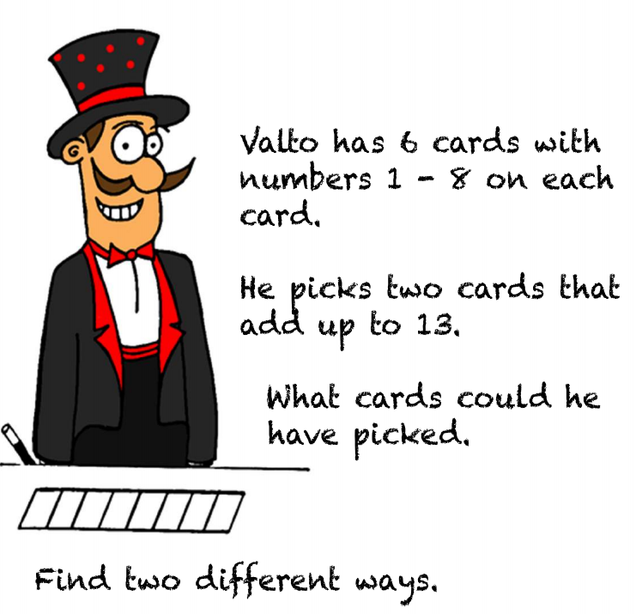

He can pick

9 and 4 (9+4=13)

This is incorrect because the numbers are from 1-8 and 9 is bigger than 8.

He can pick

7 and 6. (7+6=13)

Both numbers are between 1 and 8.

This is correct.

He can pick 5 and 8 (5+8=13)

Both numbers are between 1 and 8.

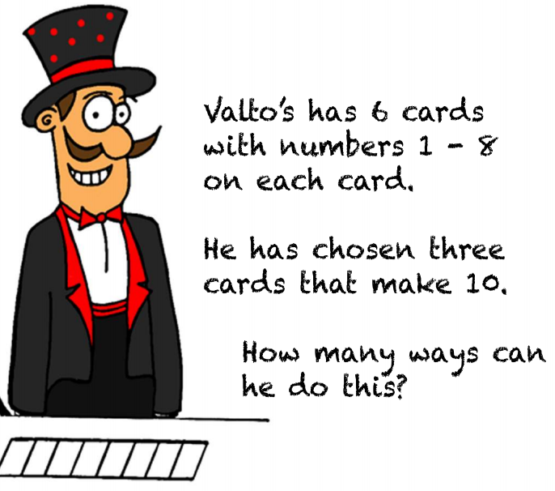

He can pick 3, 4 and 3

3+4+3 = 10.

This is incorrect because I have used 3 twice. I can only use each card once.

He can pick 1, 4 and 5

1+4+5 = 10

This is correct.

Your task- each section is a different question. Start with the top one.

