Friday 10th July 2020

To find the sum you need to add the numbers together. E.g, 21 is 2+ 1 = 3
To find the difference you need to take away the numbers from each other so 17 7 – 1 is 6..
I have chosen the number 7
This can’t be correct because the number need to be a 2-digit number.
I have chosen the number 11
This is a 2-digit number
The sum of the digits is 2 so this number is incorrect.
I have chosen the number 15
It is a 2-digit number
The sum of the 2-digits is 6
The difference between the 2-digits is 4.

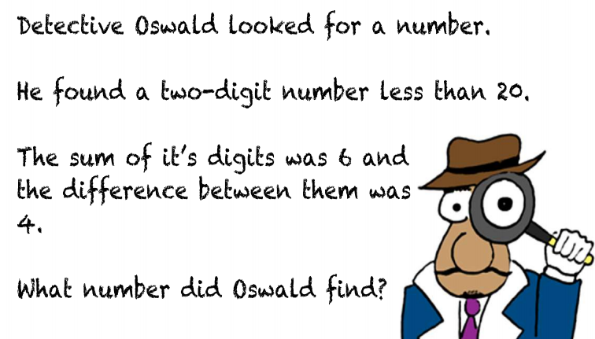

I have chosen the number 17
The difference between the 2-digits is 8. This number is incorrect
I have chosen the number 24.
The number is less than 30.
The sum of the 2-digits is 6
This means the number in incorrect
I have chosen the number 28
The number is less than 30
The sum of the 2-digits is 10
The difference between the 2-digits is 6
28 is the correct number.

