L.I:- To be able to identify and describe different types of biomes.
I will be successful if..
- I can name the different types of biomes.
- I can identify where they are found in the world.
- I can say what the differences are in biomes.
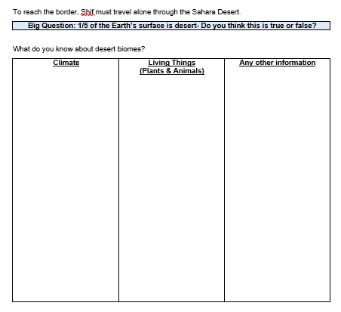
https://www.dkfindout.com/uk/animals-and-nature/habitats-and-ecosystems/land-habitats/

