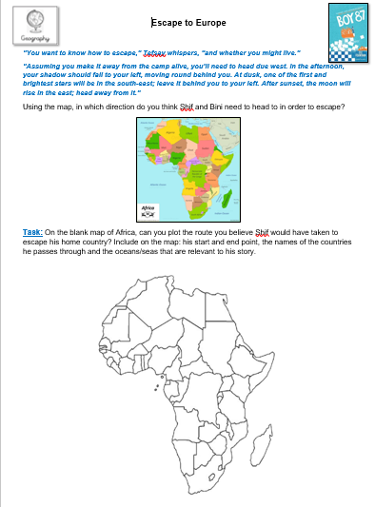
L.I:- To be able to recognise geographical boarders

