Tuesday 7th July 2020
Geography

As we have found out previously, the Vikings came from Scandinavia in Northern Europe. We know these places now as Norway, Sweden and Denmark.
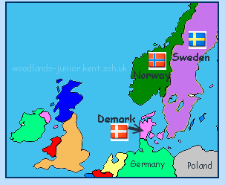

But what are the countries that they came from like today? Choose one of the countries to create a non-chronological report on.
Things to include:
- Basic facts – e.g. flag, capital, surrounding countries, borders, population, language, religion etc.
- Physical and human geography features of the country
- What it was like in the Viking age

There are many websites you can use online to help you research. A tip – type in the country you are researching and facts for kids.
E.g. Denmark facts for kids.
Some examples are:
https://www.ducksters.com/geography/country.php?country=Denmark
https://www.kids-world-travel-guide.com/denmark-facts.html
https://www.sciencekids.co.nz/sciencefacts/countries/sweden.html
https://kids.nationalgeographic.com/explore/countries/sweden/
https://www.ducksters.com/geography/country/sweden.php
https://easyscienceforkids.com/all-about-norway/
https://www.ducksters.com/geography/country.php?country=Norway
https://www.kids-world-travel-guide.com/norway-facts.html

