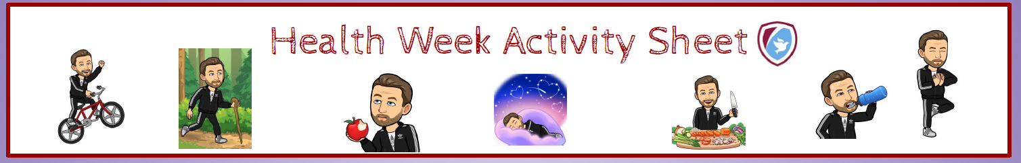
Try a #ThisIsPE Video – Lesson 6 is a good one!  https://academystjames.com/pe-physical-activity-at-home/ | Go for a bike ride – remember to wear a helmet  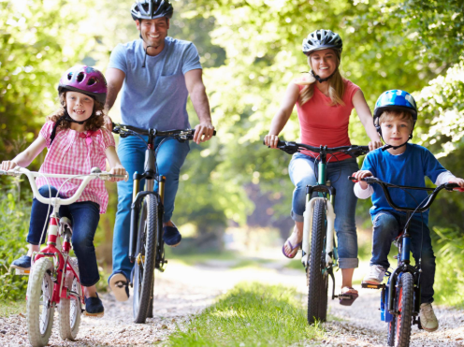 | Have a go at Zumba  https://www.youtube.com/watch?v=ymigWt5TOV8  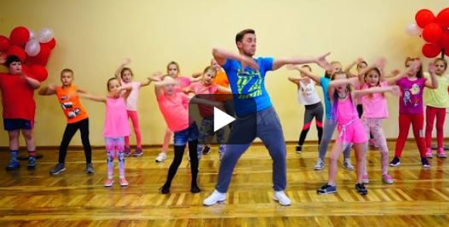
Do some mindfulness colouring  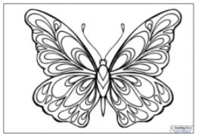 | Make your own kite and fly it  https://www.youtube.co  m/watch?v=dismSOx3q  0g  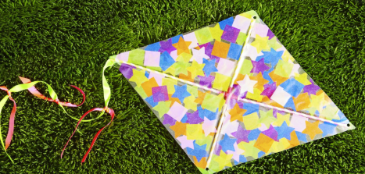 | Design a healthy snack and make it  e.g. fruit smoothie or fruit kebab  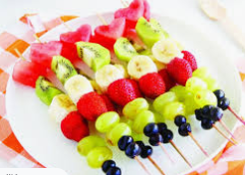
Go for a nature walk with the family and take photos of what you find/ see  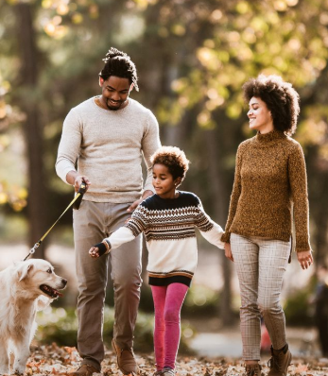 | Help your adult to cook a healthy meal for the family  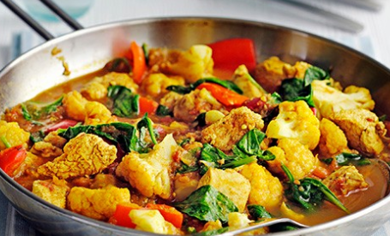 | Mindfulness – gonoodle activity  https://www.youtube.com/watch?v=O29e4rRMrV4&list=PL0PE1OVfRIs2AwJoLQoE4zru4rupVe4Ty

