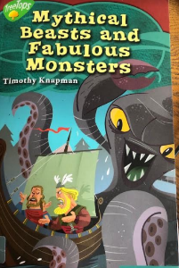
Monday 13th July 2020
Reading

- Find and copy the phrase that tells you the brothers had a successful trip finding food.

- ‘Well that settles that, we’re both right.’ What were Snorri and Halfdan both right about?

- How do you know that Halfdan isn’t afraid of dying and thinks it is a part of being a Viking?

- How do you know Snorri is trying to trick the Kraken by saying ‘kind things’?

