Monday 13th July 2020
English

Shared Ideas
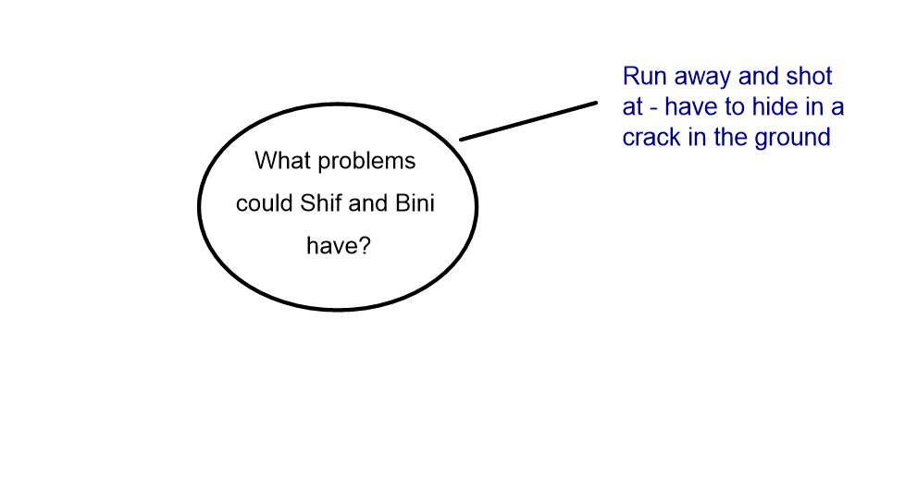

Boy 87 | Structure | My Story
Shif and Bini wait until the guard is not looking and run away across the desert. Shots are fired and they hide in a crack filled with dirt. They bury themselves underneath and stay as still as possible. The guards drive past them twice until it becomes dark. They can no longer see the camp. | Problem 1

