Monday 13th July 2020
This week we are going to be moving on and writing another genre of writing.
Can you make predictions about what you believe we will be writing? A letter? Another non-chronological report? A story? A comic strip?
Please write a paragraph and not write in the boxes as that is a word bank to support your writing.
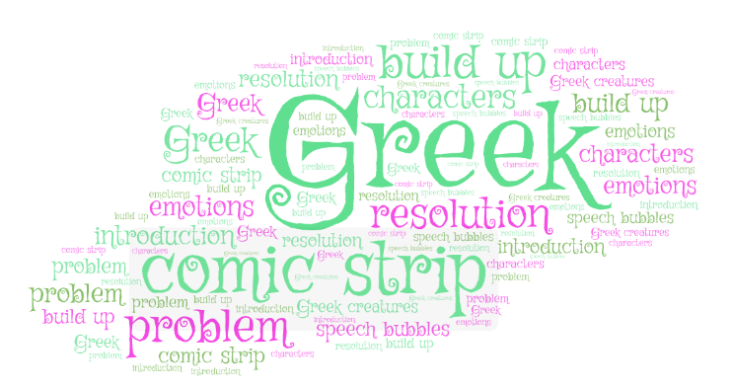

I predict that… | After looking at the image, I believe… | After discussing it with my family…
The genre of writing we are writing is.. | The word…. gives me the impression that… | The shape of the word cloud tells me that…

