Monday 13th July
RE – Prayers

Over the last couple of weeks, we have been learning about how different faiths can work together as a community and how they can make Bradford a more respectful place.
This week, we are going to write prayers to ask for help with this.
Have a look at the following religious quotes – they all remind us that we should have respect for everyone and treat everyone the same.
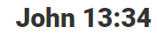 (Bible)

"O mankind! We...made you into nations and tribes, that ye may know each other (not that ye may despise each other)." (The Qur'an 49:13)
“All mankind is from Adam and Eve. An Arab has no superiority over a non-Arab nor a non-Arab has any superiority over an Arab; also a white has no superiority over a black nor a black has any superiority over white except by piety and good action.”

(Guru Granth Sahib – Sikh)
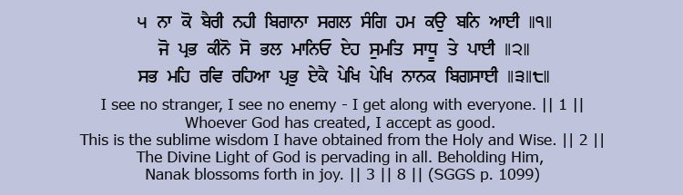

Why do people pray?
Watch the following video clip about the different reasons why people pray.
https://www.youtube.com/watch?v=ZrdlXOk_QdQ
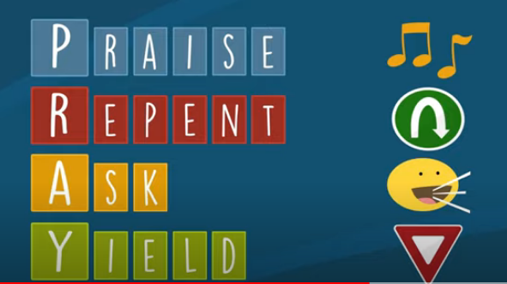
We are going to write a prayer to Ask God to help us respect everyone and to work together as a peaceful, harmonious community.
Have a look at the following prayers – they are asking God to help us respect everyone:
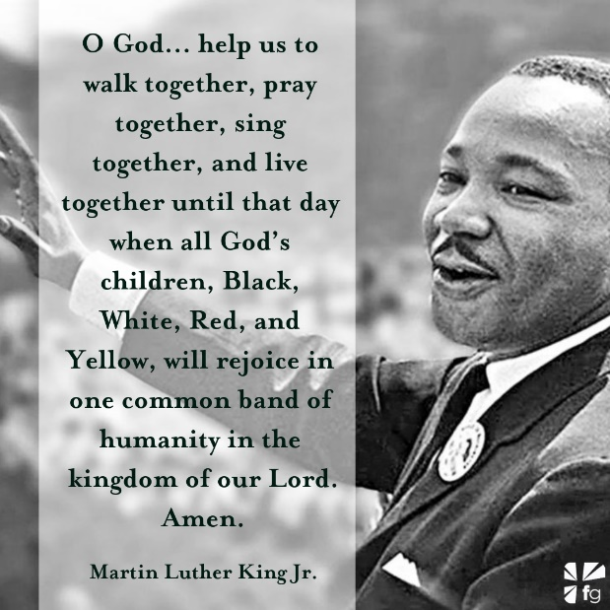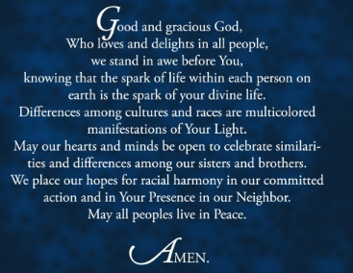
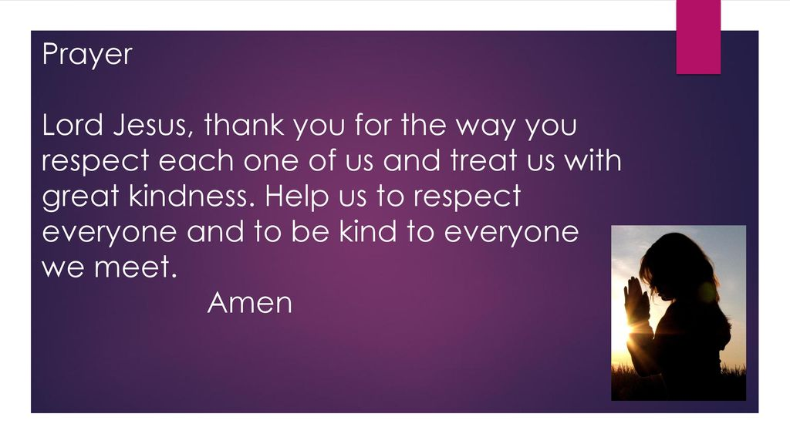
Your turn – write a prayer to God that we could use in school, to ask God to help us work together peacefully and respectfully as a community.

