LI: To order and compare negative numbers
To use negative numbers when solving word problems.

Order these from smallest to largest:
-345 +321 -34 -4 +4

-77 -67 +6 +7 +67

+809 +908 -908 -809

-17 -16 +34.5 +34.4

+5 - 7 +2 +10

-11 +11 -3 +5

-4 -1 +4 +1

-12 -11 -2 +6 +8

Use < and > to compare these: Use < and > to compare these:
-345 -354

-456 -15

+48 -48.8

-89 -99
-7 -5

+5 -2

0 -5

-18 +18

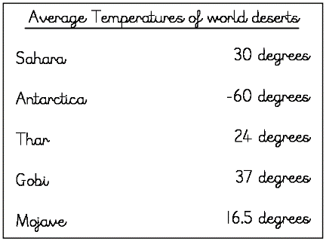
What is the difference in temperature between Antarctica and the Sahara?
At night, the temperature in the Gobi Desert decreases by 36 degrees. What is the temperature in the Gobi Desert at night?
What is the difference in temperature between the Antarctic and Gobi deserts?
If the temperature in the Mojave Desert decreases by 34.5 degrees, what would the new temperature be?

