Monday 6th July 2020
Reading

As we have finished the Vikings in 30 seconds book, we are going to link the next few whole class reading books to our overarching theme – Magic, Monsters and Mayhem. We fill be focusing on all things monsters!

The first short story we are going to look at is called The Watcher in the Waves.

Prediction
Other than the story being about monsters. What do you predict this story will be about?
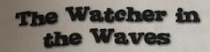
Modal Verbs
Could May Should
Might Will

I predict…

Have a think of any other stories you have read that contain monsters in them. They should have a ‘defeating the monster’ plot structure. Write down as many as you can (age appropriate please).
