Monday 6th July
Expanded Noun Phrases

As we are focussing on narrative (writing stories) over the next week or so, we need to make sure we have remembered how to write and use expanded noun phrases.
Re-cap
What is a noun?
What is a noun phrase?

Watch the video to remind yourself:
https://www.youtube.com/watch?v=GlGJ8gANeGo

Now you have remembered what a noun phrase is, what is an expanded noun phrase?
These might help to remind you:
https://www.youtube.com/watch?v=WhEoRVNJfDs (song)
https://www.youtube.com/watch?v=4fCk8ye4jio

Now have a go at these grammar questions about using noun phrases.
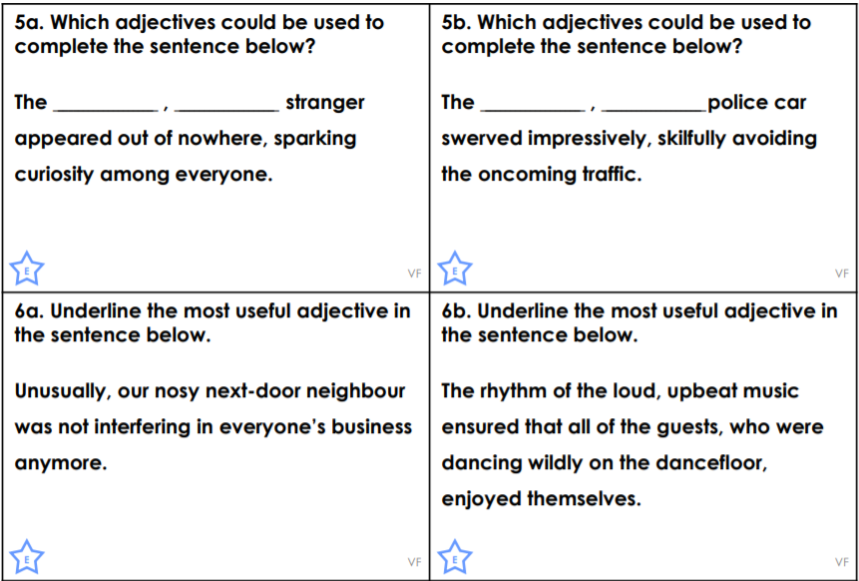
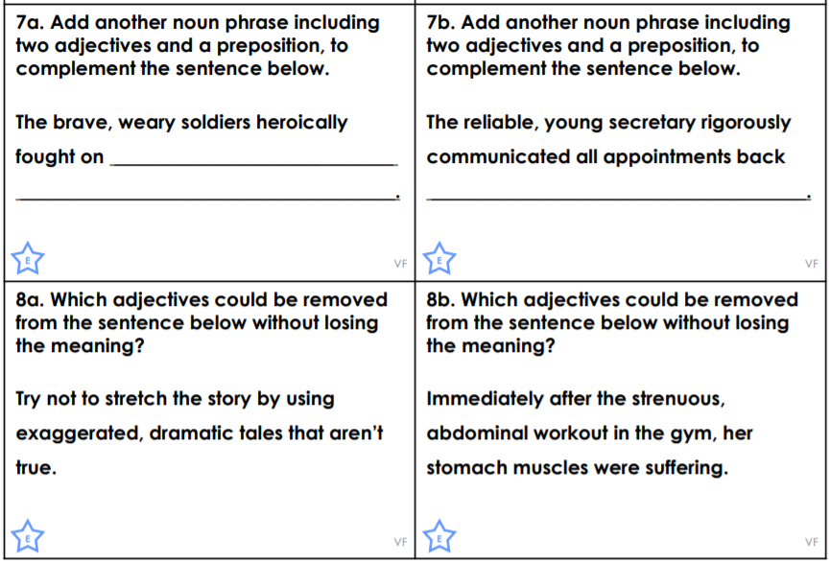

Challenge
