Monday 6th July
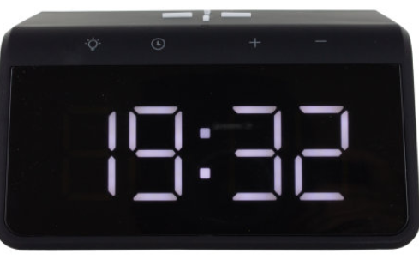
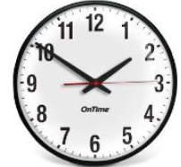
Telling the time

What are you like at telling the time? It is one of the hardest concepts in Maths to get to grips with because it doesn’t work in base 10 like everything else- place value columns don’t work for telling the time.
We are going to start a learning journey using digital times and calculating with time. Before we can do this, you need to be able to tell the time.
Have a go at these assessment questions below. If you find these difficult and are finding it hard to tell the time on an analogue clock to the nearest 5 minutes, then please use the mymaths links and practise that.
Mymaths links:
https://app.mymaths.co.uk/5936-lesson/telling-the-time-to-5-mins
https://app.mymaths.co.uk/288-lesson/telling-the-time-2
https://app.mymaths.co.uk/290-lesson/time-calculations
(If you need the mymaths log in again, please ask on dojo, classroom or by email)
You will need to be able to use digital clocks to and to know what they mean.

To answer the questions below on a laptop or chromebook, please see loom video on how to do it:
https://www.loom.com/share/ef75dcd289b842d9a25695d73cb4f636

Assessment Questions – telling the time (taken from Year 3 and 4 curriculum)



 