Monday 6th July
RE – How have different faith groups supported their communities during lockdown?
Re-cap – Islam
Arrange these pictures of Wudu in the correct order to show how Wudu is performed.

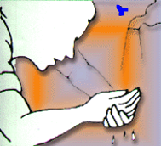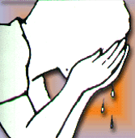
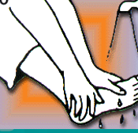

Last week, you designed a community event to bring the people of our school community together.
Why is it important that people of all faiths come together as a community? What would happen if they didn’t?

Since lockdown started, places of worship have not been allowed to open and their congregations/worshipers have been unable to gather in the buildings. So how have different religious groups managed to still support their communities?

Look at the headlines below – what do these tell us about the work the different groups have done for the community? How have they all come together in a time of crisis?
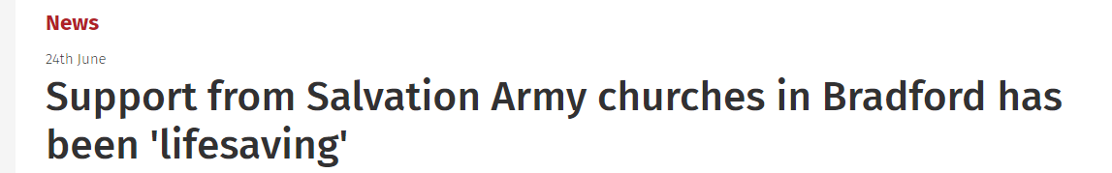
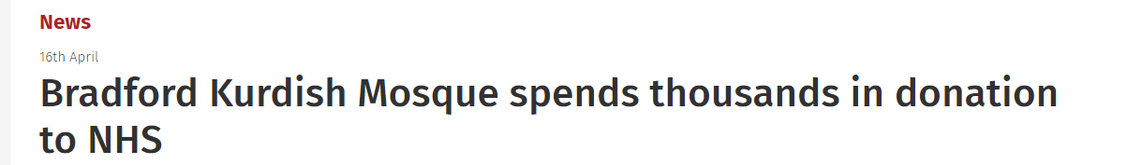
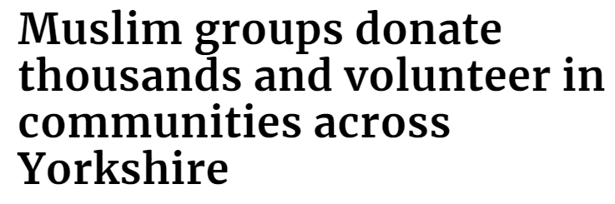
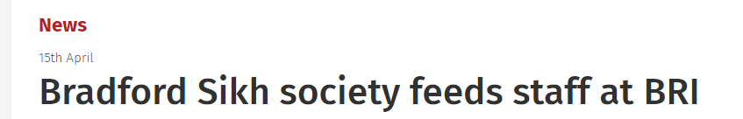
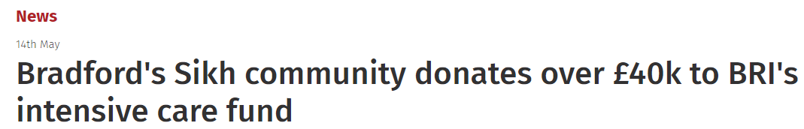

Use the links to the news articles below and read about what the different faith groups have done for the community during Lockdown.
Make your own news report about how the different faith groups have come together to help/ support their community.
This could be in the form of a written newspaper report, a powerpoint presentation or even a news video with you reporting.
https://www.thetelegraphandargus.co.uk/news/18450724.bradfords-sikh-community-donates-40k-bris-intensive-care-fund/

https://www.thetelegraphandargus.co.uk/news/18381759.bradford-sikh-society-feeds-staff-bri/

https://www.yorkshirepost.co.uk/health/coronavirus/muslim-groups-donate-thousands-and-volunteer-communities-across-yorkshire-2542054

https://www.thetelegraphandargus.co.uk/news/18502184.amazing-army-bradford-volunteers-stepped-help-citys-vulnerable-covid-19-crisis/

https://www.thetelegraphandargus.co.uk/news/18381570.bradford-kurdish-mosque-spends-thousands-donation-nhs/

https://www.thetelegraphandargus.co.uk/news/18539378.support-salvation-army-churches-bradford-lifesaving/

