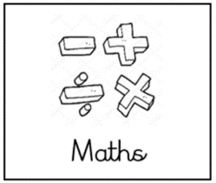**Boy 87– Maths Activity 3**

(Ordering & comparing numbers, interpreting decimals, addition)

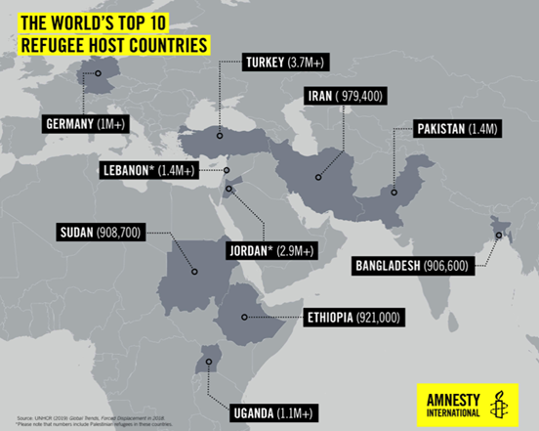

1. Tell me the story.
2. What do you notice about the countries that hosted the most refugees in 2019?
3. Which country in the story hosted the most refugees in 2019?
4. Which country in the story hosted the least refugees in 2019?
5. Order the countries from the most to least refugees that were hosted in 2019.
6. Approximately, what was the total number of refugees that were hosted by the countries in the above story in 2019?

**Extension activity** 🡪 Can you research and find out why these countries host the most refugees?