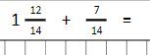
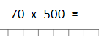
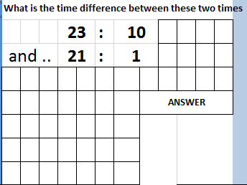
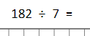
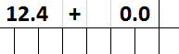
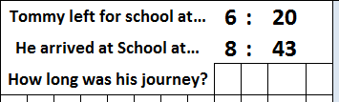
Morning Maths Thursday 16th July

