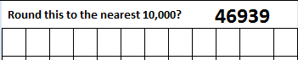
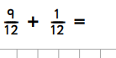
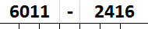
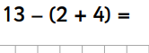
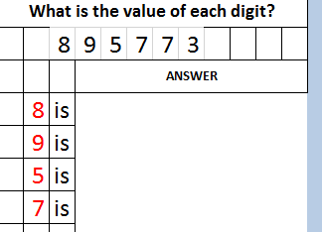
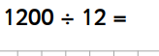
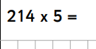
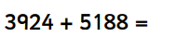
Morning maths – Tuesday 7th July 2020

