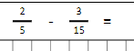
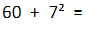
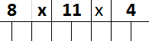
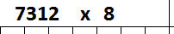
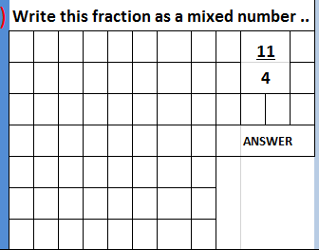
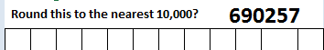
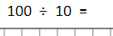
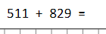
Morning Maths Monday 13th July

