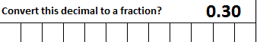
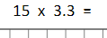
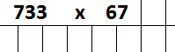
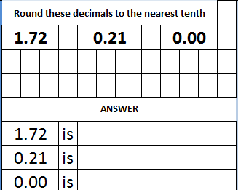
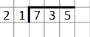
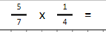
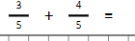
Morning maths Wednesday 15th July

