Wednesday 8th July 2020
PE

Agility and Throws
This lesson is following the video clip produced by This Is PE.
You can find the video on their website: https://www.afpe.org.uk/thisispe-supporting-parents-to-teach-pe-at-home/
Lesson 14 – Sock Wars

Activity 1 – Attack v Defence
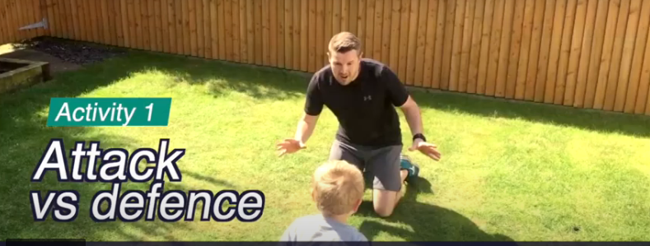
The defender tucks a sock into the back of their waistband of their trousers/shorts.
The attacker is aiming to grab the sock while the defender is trying to avoid that happening.
Make sure the playing space is free of obstructions, hazardous objects and sharp corners.
When defending, use quick changes of direction to dodge the attacker.
When attacking, keep your eyes on the target and use explosive lunging actions to grab the sock.

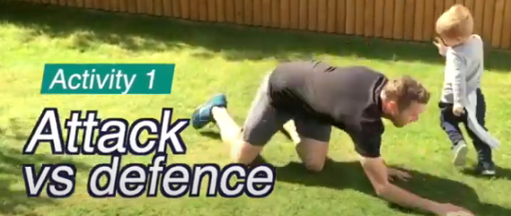

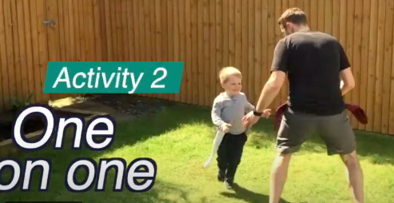
Activity 2 – One on One
In this activity, each player places 2 socks in their waistband, one on each hip.
The aim is to be the first person to remove both of your opponent’s socks.
You now need to think about protecting your own socks as well as grabbing your opponents
Make it easier
Use longer length socks
Stick the one sock

Make it harder
Use shorter socks
Use more socks
Only use one hand
Play on your knees

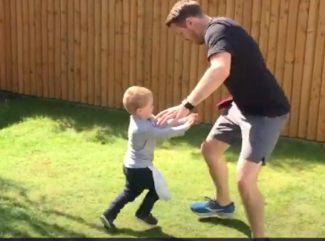

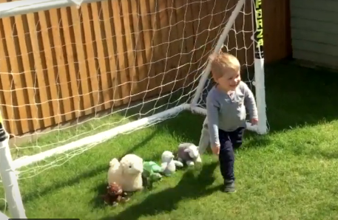
Activity 3 – Teddy Collect
Place 5 teddies (or other objects) at either end of the playing area. Each player will need 2 socks tucked into their waistband at the hips.

Taking it in turns, each player will attack their opponent’s end to grab a teddy and return it to their own end. Only 1 teddy at a time!

If the defender manages to grab a sock from the defender at any time of their attempt, the teddy must be returned to where it was.

Remember to use your body position, explosive speed and quick changes in direction but most of all, have fun!
