Thursday 9th July
Viking Raiders Vs Settlers (revision)
Over the last term, you have been learning about the Vikings and what they were really like. Vikings were known for being either Raiders or Settlers – What is the difference? This lesson will help you to re-cap what you have learnt about the Vikings and to consolidate your knowledge.

Have a close look at the picture below. Look for clues that this is a Viking raider and label the picture. How do you know that these Vikings weren’t just here to settle?
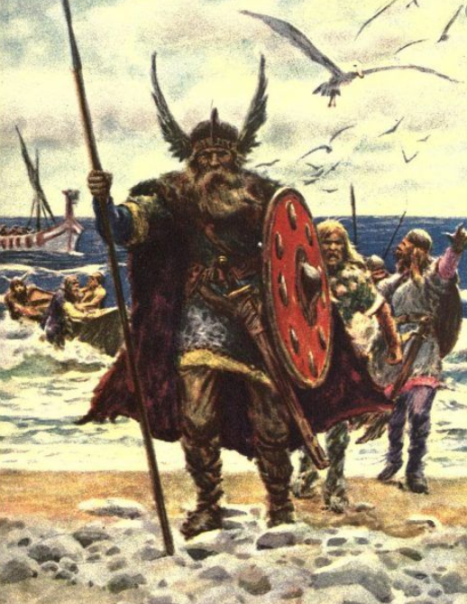

So how do we recognise the Viking settlers? How are they different?
Look closely at the picture below and label the clues to show that these Vikings were here to settle.
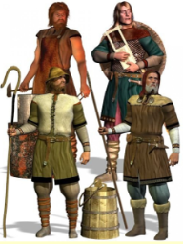

Viking Raids
The first Viking raid recorded in the Anglo-Saxon Chronicle was around AD787. It was the start of a fierce struggle between the Anglo-Saxons and the Vikings. The Vikings were pagans, not Christians like most people living in Britain at the time. They did not think twice about raiding a monastery. Christian monasteries in Britain were easy targets for the Vikings. The monks had no weapons and the buildings were filled with valuable treasures, like gold, jewels and books. There was food, drink, cattle, clothes and tools too – all very tempting to a Viking raider.
​​​​​​​Over several years the army battled through northern England, taking control of the Anglo-Saxon kingdoms of Northumbria, East Anglia and most of Mercia. By AD 874, almost all the kingdoms had fallen to the Vikings. All except for Wessex, which was ruled by Alfred the Great. King Alfred beat the Viking army in battle but wasn’t able to drive the Vikings out of Britain.

Watch the video below to remind you about the Viking invasions and the order of events.

https://www.youtube.com/watch?v=VLLYzSMB5RA&feature=youtu.be

Arrange the events on a timeline to show the chronological order of events.

Timeline

Have a look at inspire education and explore the Viking Shipyard.
This will help you to consolidate your knowledge about Viking raiders.

https://www.inspire.education/
(Your username and password was shared on dojo a while ago. We will share it again)
Click on History, then Vikings, then explore the Shipyard

Watch the loom video to see what Inspire Education is like and where to go.
https://www.loom.com/share/a82556563d0b44018368158b4fb53884

