Thursday 9th July 2020
Science

Materials and their properties

Memory Quiz – match the vocabulary to the correct definition

See through, like glass.
Opaque

Can be dissolved, like coffee granules.
Electrical Insulator
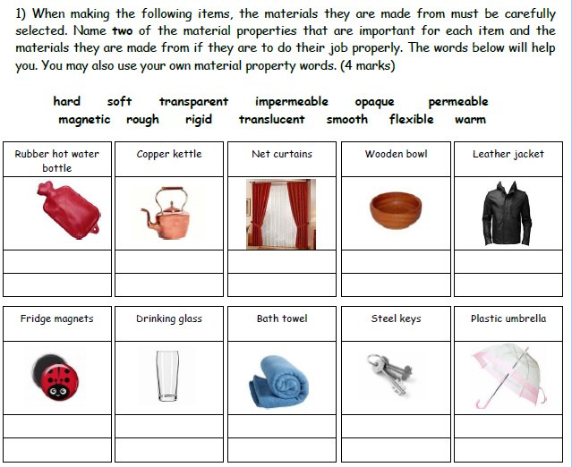
Transparent
Thermal Conductor
Lets heat pass through easily, like a metal kettle.
Not able to be seen through
Do not let electricity flow through easily, like plastic or rubber.
Soluble

