**Thursday 9th July 2020**

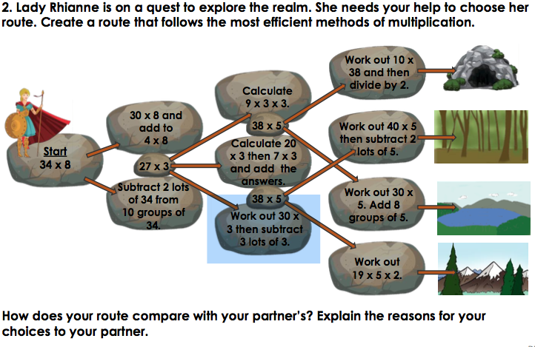 Try these divisional and multiplication problems:

