Thursday 16th July 2020
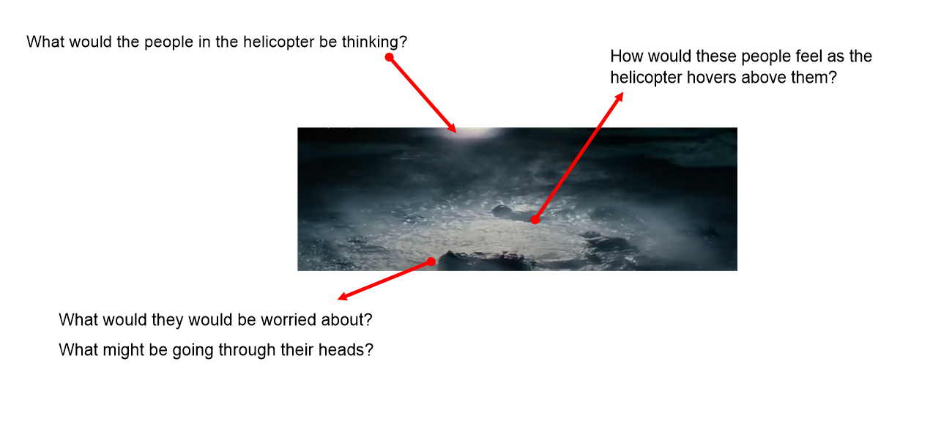
English

Boy 87 | Structure | My Story
A helicopter arrives just as they have lost all hope. Shif and Almaz are pulled up to safety into the helicopter. They are in a bad way but alive. | Resolution

