LI: To convert between units of time and apply it to reasoning and problem solving questions.
How many hours are there in a week?
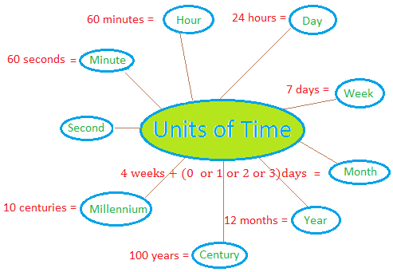

How many minutes are there in an hour?

How many seconds are there in 5 minutes?
How many days are there in 5 weeks?

How many weeks are there in 2 years?
How many months are there in a year?
How many days are there in a leap year?

How many years are there in a decade?

(If you don’t know, research it or message us and we can help!)

Convert these units of time

Write in minutes:
6 hours
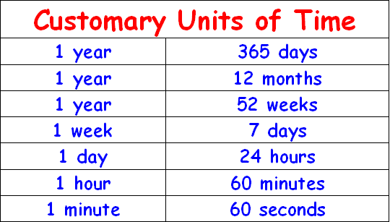
12 hours
A quarter of an hour
360 seconds
20 hours

Write in weeks:
49 days
6 years
140 days
20 years
8 decades

Write in years (and months if needed):
60 months
19 decades
6 millennia
37 ½ decades
144 months

Reasoning – True or false? Explain why
There are 130 months in a decade.

There are 53,000 weeks in a millennium.

There are 1,440 minutes in 1 day.

There are 98 hours in 4 weeks.

There are 1,600 seconds in half an hour.

There are 86,400 seconds in 1 hour.

There are 5,000 minutes in 3 days.

