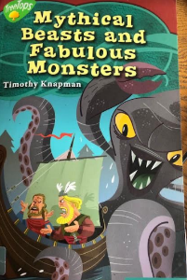
Thursday 9th July 2020
Reading

3:2:1
Thinking of the main character Snorri, we want you to tell us 3 things you know, 2 things you don’t know and 1 question you would like to ask him.

3 Things I Know | 2 Things I Don’t Know | 1 Question I want to ask him

