Thursday 9th July
Consolidating timetable questions from yesterday

Have a go at these:
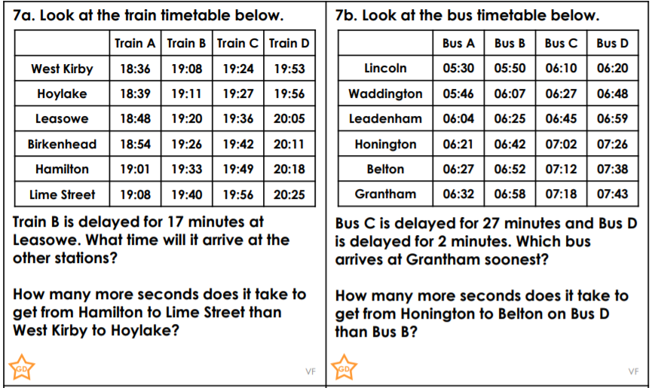
Problem solving involving time
Example
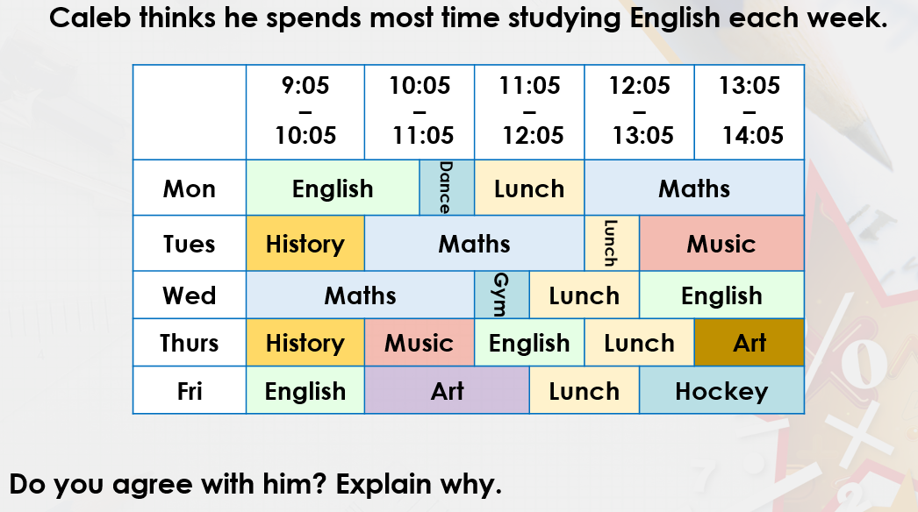
See loom video for explanation:
https://www.loom.com/share/032c34ba84ae4a748cf86c30b7acfffb
Looking at the timetable, we can see that Monday he has 1 ½ hours of English.
Tuesday he as no English. Wednesday he has 1 ½ hours of English, Thursday he has 1 hour of English and Friday he has 1 hour of English.
Altogether, that’s 5 hours of English.

Looking at his Maths though, he has a 2 hour Maths lesson on Monday. He also has a 2 hour lesson on Tuesday and a 2 hour lesson on Wednesday.
This means he has 6 hours of Maths.
The answer is therefore, no, I don’t agree as he spends more time doing Maths.
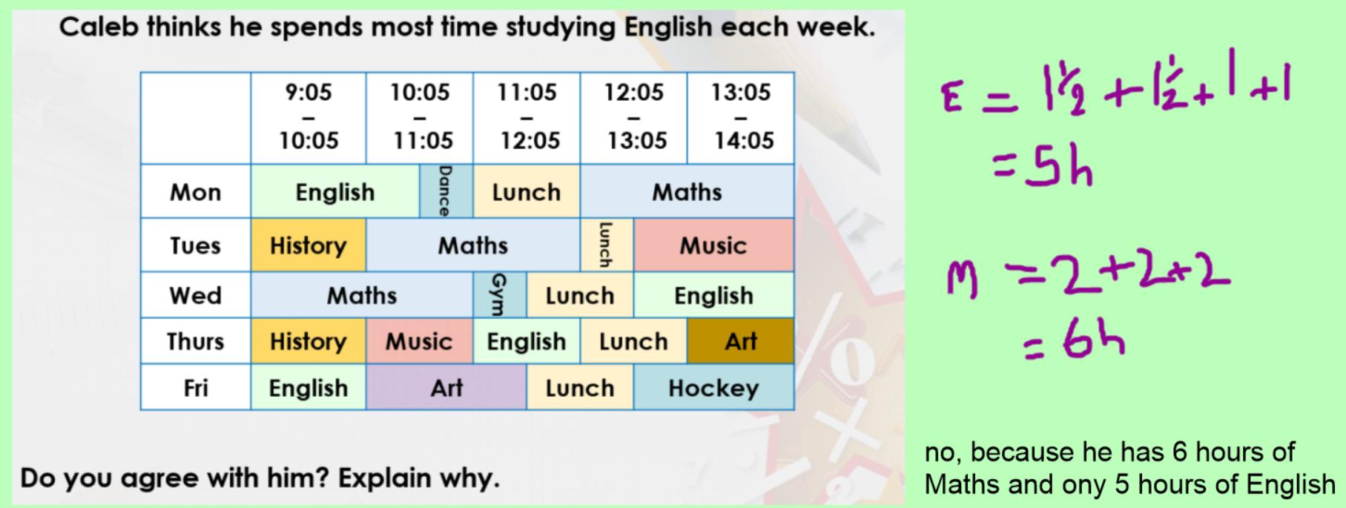

Your turn:
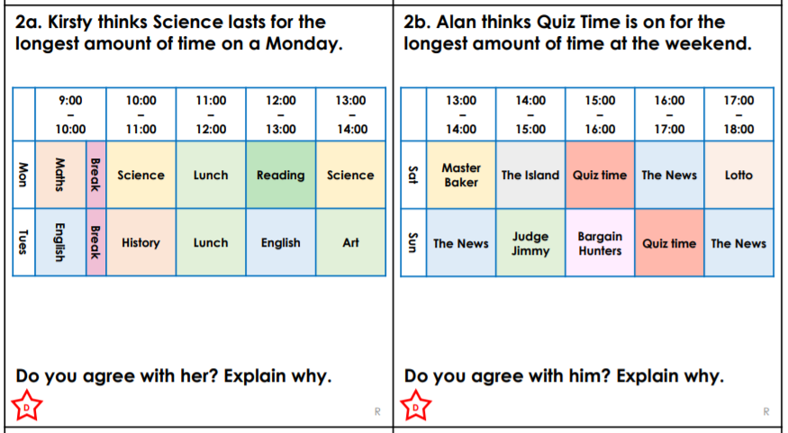
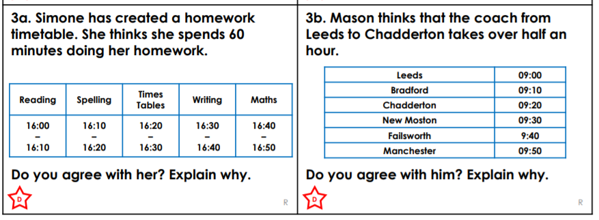
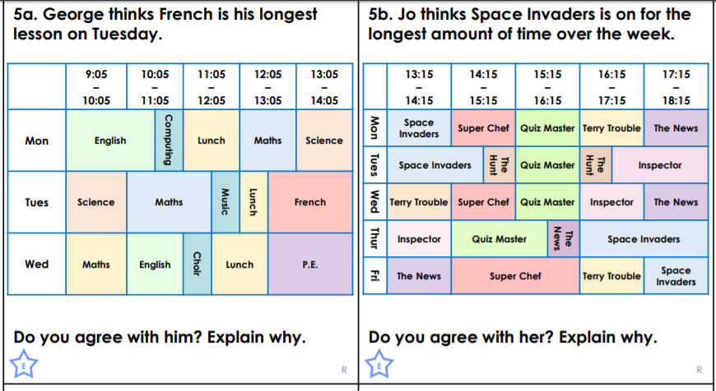

Challenge
