Thursday 9th July
Rags to Riches Plot and character study

Re-read the WAGOLL and familiarise yourself with it again.

Let’s think about the character of Hiccup. Last week, we completed an axis of emotion for Hiccup, but how does his character change throughout the story?
What is he like at the beginning, in the middle and at the end of the story?

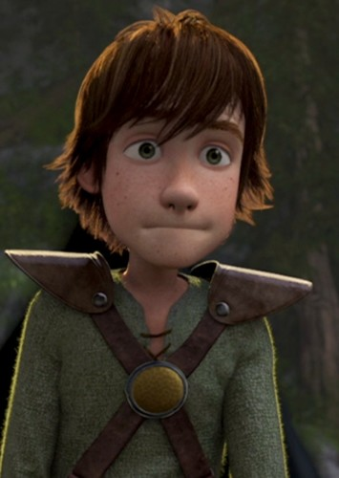
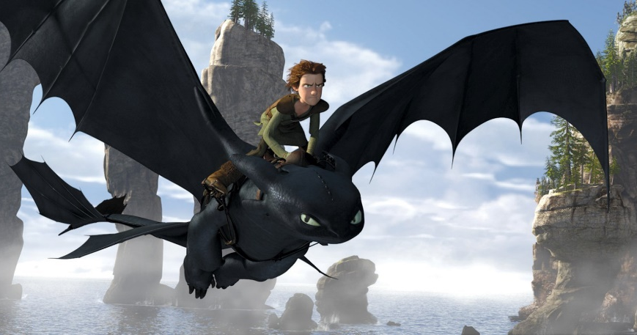
Character Study

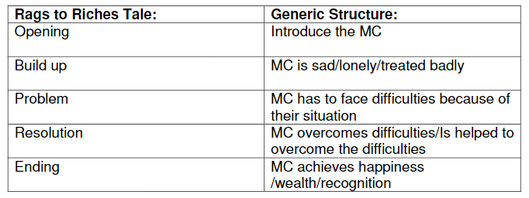Explain how Hiccup’s character changes throughout the story.
How does it follow the plot structure of a ‘Rags to Riches’ story?
How would Hiccup change as a person? Would he act differently at the beginning to the end?

At the beginning of the story, Hiccup….
In the middle of the story, Hiccup…
At the end of the story, Hiccup…

Once you have done that, add Hiccup’s characteristics to a role on the wall.
On the outside, add his characteristics at the beginning of the story and on the inside, add his characteristics at the end of the story.

