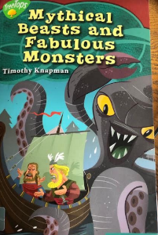
Tuesday 14th July 2020
Reading

Pages 40-43

Statement | True/False | Prove It
The Kraken is not very clever.

Aegir makes Rune Juice for very important people.

Halfdan doesn’t really understand Snorri’s plan.

The Kraken trusts Snorri when he goes to Aegir’s’ golden hall.

Aegir is very welcoming towards Snorri.

