Tuesday 7.07.20
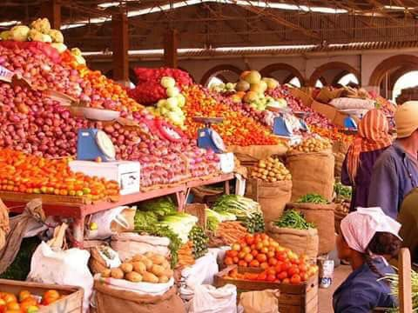
LI: To solve word problems involving money and measures.
I will be successful if:
I can read the question and identify the ley information.
I can identify what type of calculation to do and carry it out using efficient written or mental methods.
I can convert units of measure if necessary.

These word problems are based on shopping at the market in Boy 87.
If you need help with how to tackle the word problems, please see the loom video below that explains what you need to do to be able to work these out.
https://www.loom.com/share/e4a024414b6e4c43847694a8326b2173
https://www.loom.com/share/57fd26b439324ee6a455d0e4498ca734

- 12 injera (flatbreads) cost 10 nakfa. How much would it cost for 60?

- Cumin comes in packs weighing 175g. If I buy 9 packs, how much will I have in grams? How much would I have in kilograms?
- I buy a sack of teff (grain) for 50 nakfa. Each sack contains 15kg of grain. If I buy 9 sacks, how much will it cost? What weight would I have? What’s the weight in g?
- Ready-made birsen (curried lentils) is sold by the bowlful. Each bowlful contains 400g. If I buy 4 bowlfuls, how much will I have in kg?
- If 1kg of mphodza (lentils) costs 25 nakfa. How much does 4.5kg cost?
- Shahee (tea) is sold in 2.5 litre jugs for 14 nakfa. How much would it cost for 500ml?

- I have 36 nakfa to spend. If 4 injera (flatbreads) cost 3 nakfa, how many can I buy?

