Tuesday 7th July 2020
Today you are going to write the introductory paragraphs to your conquering the tale story. This is one taken from the WAGOLL. Be clear and descriptive when describing your setting and your main character.

The sun beat down on the dry, dusty grounds as hundreds of people swarmed around the half-finished Parthenon like ants. Everyone was busy. All around you could hear the tap-tapping of chisels as people carved the huge blocks of stone needed for the construction. When each stone was finished it was loaded onto a wooden sledge and wrapped in long ropes. Hundreds of people would then drag it up a large ramp towards the top of the Parthenon.

Athena, the Greek goddess, watched with fascination. As a goddess of wisdom, it was her job to protect the Parthenon. Construction had taken 10 years already but Athena knew it would be worth it as people were building it for her.

The Parthenon was already impressive, thought Athena, even though it was not yet finished. Placed high above Athens, it reached up high towards the heavens. When it was completed, it would be able to be seen for miles and miles. Surely, there could not be a more magnificent sight in the whole world? Then everyone would know just how powerful the Greek goddess of wisdom was!
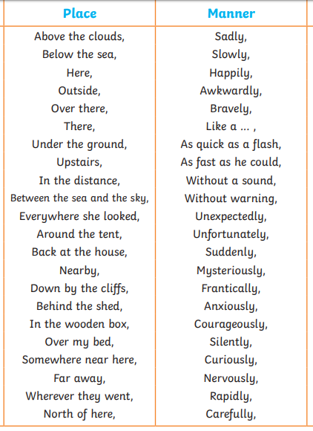
Here is a word mat to support your sentence openers.

