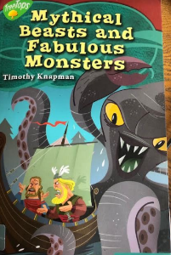
Tuesday 7th July 2020
Reading

- Other than the text stating ‘spring forgot to come to one particular Viking tribe’. Find and copy two things that show the setting is in the winter months.

- True, False, Prove It

Statement | True/False? | Prove It
The people of the village are very happy

The men and women all agree that Olaf’s plan is a good one

Most of the men are all ready and willing to fight

- Why is Snorri The Dreamer different to everyone else?

