Tuesday 7th July
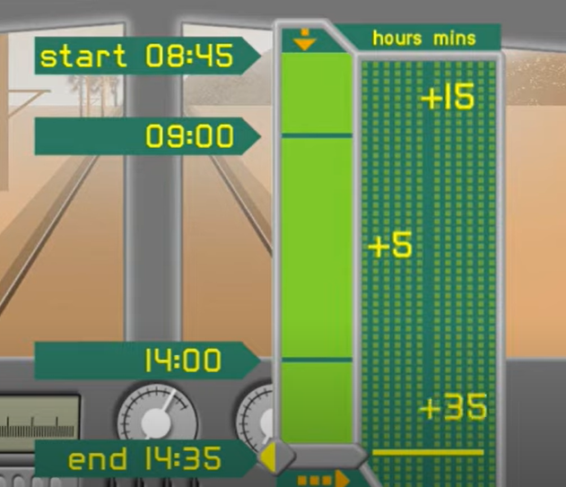
Calculating with time on a number line

Watch the following Maths Mansion video – Doing time
https://www.youtube.com/watch?v=gpNR2p2BwSA
As you watch it, look at how they calculate using time. They use a vertical number line.

Calculating with time
Example
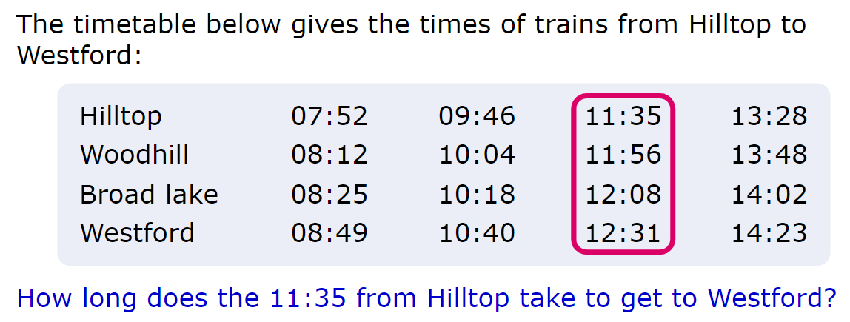
See loom video for explanation:
https://www.loom.com/share/bc93356c9c9b43d8bd2f96e01e599677
We draw a number line and start at 11:35. We then add on minutes until we get to the nest hour.
11:35 + 25 min would make 12:00
We then count on more minutes until 12:31 so we need 31 more minutes.
25 mins + 31 mins = 56 mins altogether.
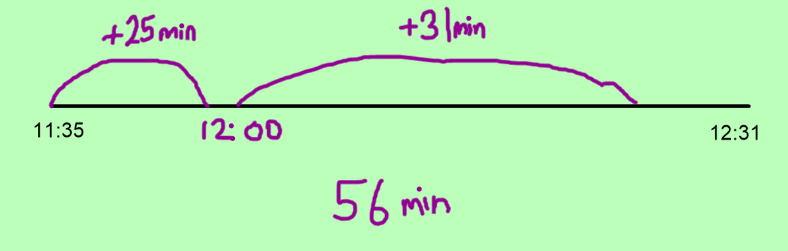
Example 2
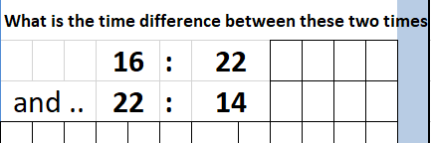
See loom video for an explanation:
https://www.loom.com/share/25e76cb732dc4eedb7fc50c85c6373c6

Draw a number line again. Start at 16:22 (which means 4:22 in the afternoon) and count how many minutes until the next hour.
16:22 + 38mins = 17:00
Then we need to count how many more hours until 22:00.
17:00 + 5 hours = 22:00
Then we need more minutes to get to 22:14.
22:00 + 14min = 22:14.

Add up the hours and minutes that we added on.
38 mins + 14 mins + 5 hours = 5 h 52 min

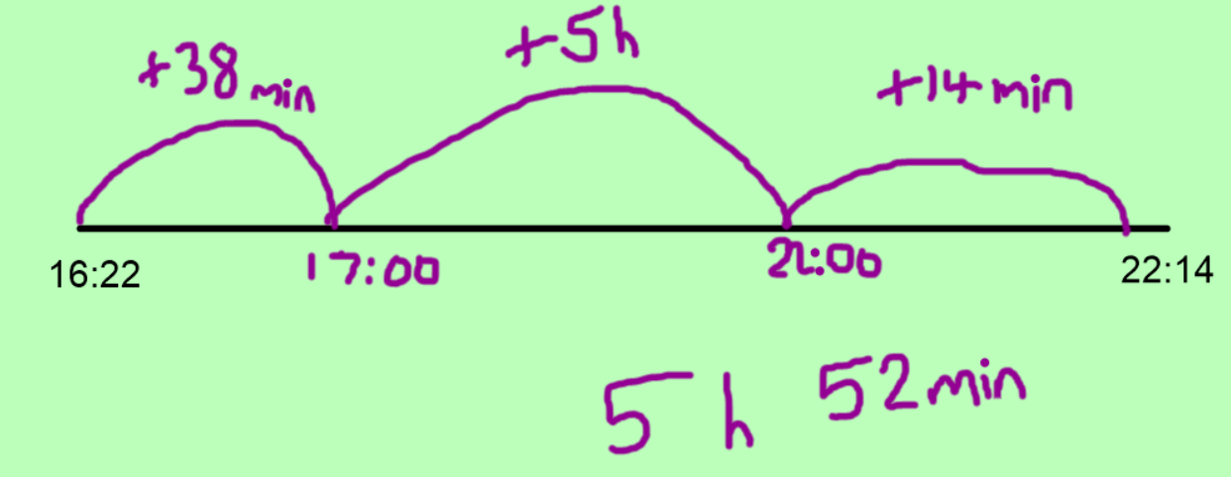

Your Turn – Have a go at these time questions
- Charlotte catches the bus for school at 07:47 and arrives at 08:25. How long did the journey take?
- A train leaves Plymouth at 09:45 and arrives at London at 13:40. How long does the journey take?
- A plane took off from Plymouth Airport at 11:47 and landed at London Gatwick at 13:32. How long was the flight in hours and minutes?

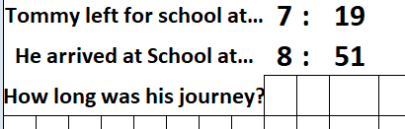

- 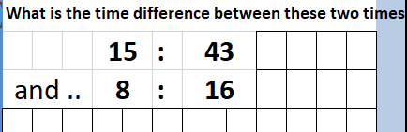

- 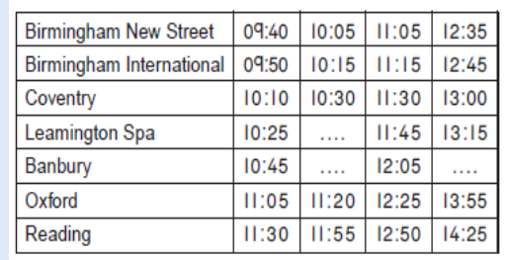
James got the 09:40 train from Birmingham New Street and arrived in Reading at 11:30. How long was the journey?

