Questions for pages 161-174
- Why do you think the author used the verb barked when Professor McGonagall said “out Peeves!”?
- Why was Wood speaking excitedly?
- Find and copy 2 verbs to describe how Ron was feeling when Harry was speaking to him?

Below is a statement linked to the pages we have read.
Think about the evidence you can think of to agree and disagree with it. Share your ideas with the adults – we would love to see your ideas written down, in voice or video recordings!

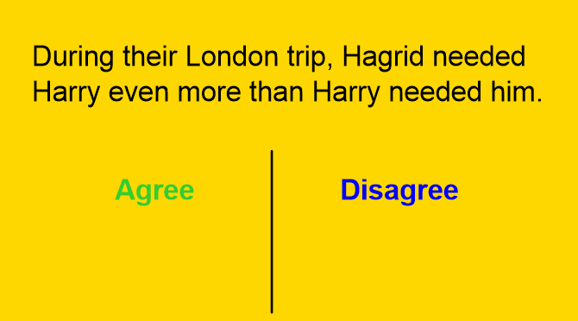
Ron should be jealous of Harry as he is better than his brother, Charlie Weasley.
[Grab your reader’s attention with a great quote from the document or use this space to emphasize a key point. To place this text box anywhere on the page, just drag it.]

