Wednesday 15th July 2020
Reading
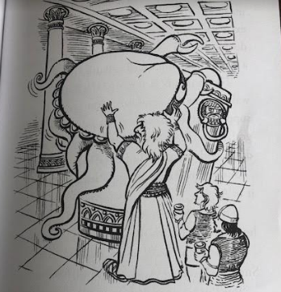

Prediction
Explain what has happened to the Kraken…

