Wednesday 15.07.20
LI: To convert units of time
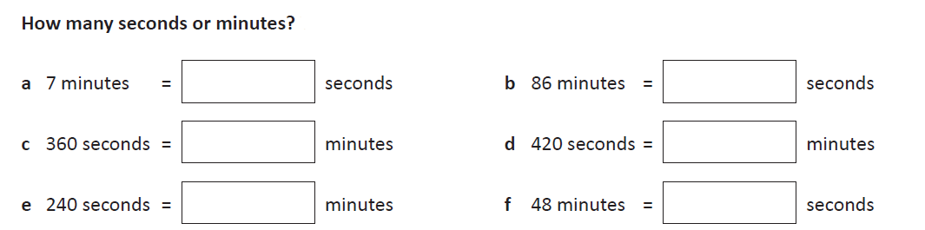
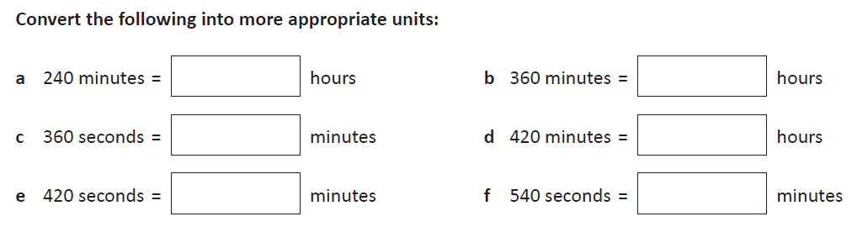

Solving problems with time
