Wednesday 8th July
Timetables

Examples for reading timetables:
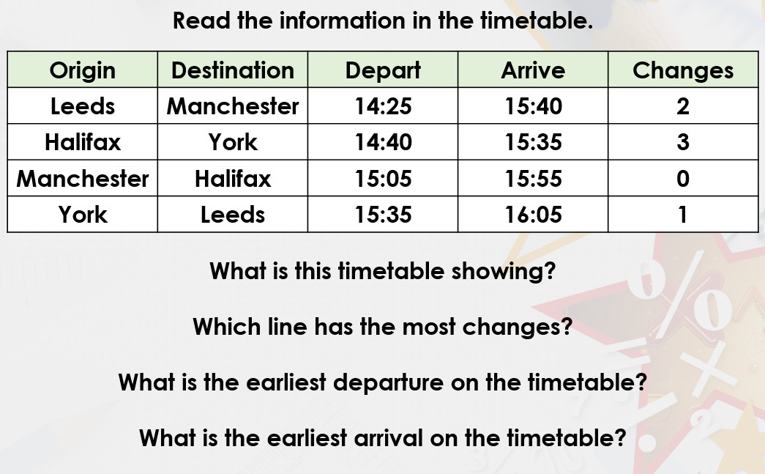
It shows us the different train departure and arrival times.
The train from Halifax to York has 3 changes.
The earliest departure is Leeds to Manchester at 14:25.
The Halifax to York train arrives at 15:35.

Example 2
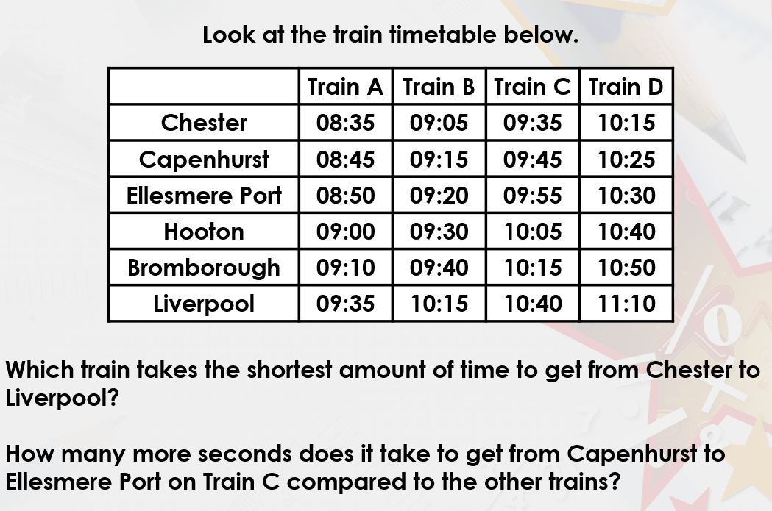
Watch the loom video for an explanation:
https://www.loom.com/share/a11256b6b5ea4e6084770530f8c50869

You could use a number line to find the difference between the start and end times of the journey, but I think you will be able to do it mentally.
Train A from 08:35 until 09:35 takes 1 hour
Train B from 09:05 until 10:15 takes 1 hour and 10 mins
Train C from 09:35 until 10:40 takes 1 hour and 5 mins
Train D from 10:25 until 11:10 takes 55 minutes.
Therefore train D takes the shortest amount of time.

Train C take 10 minutes to get from Capenhurst to Ellesmere port. There are 60 seconds in 1 minute therefore it takes 60 x 10 = 600sec.
All of the other trains take 5 minutes to get to Ellesmere port which is 300sec. Therefore train C takes 300 more seconds to get there than the other trains.

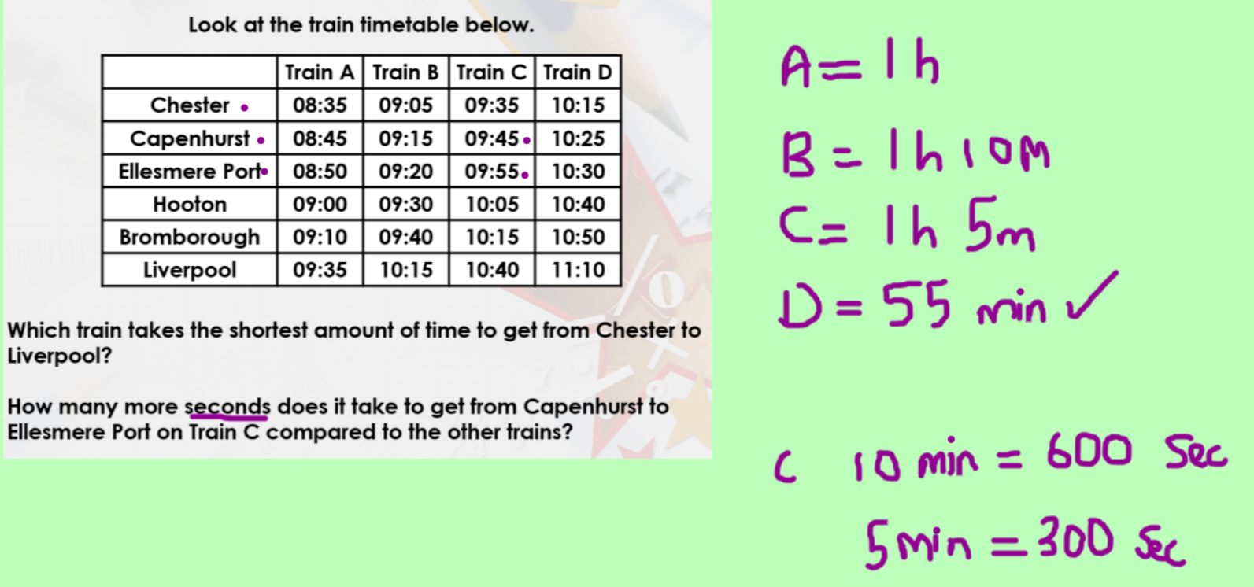

Your turn – have a got at these fluency questions:

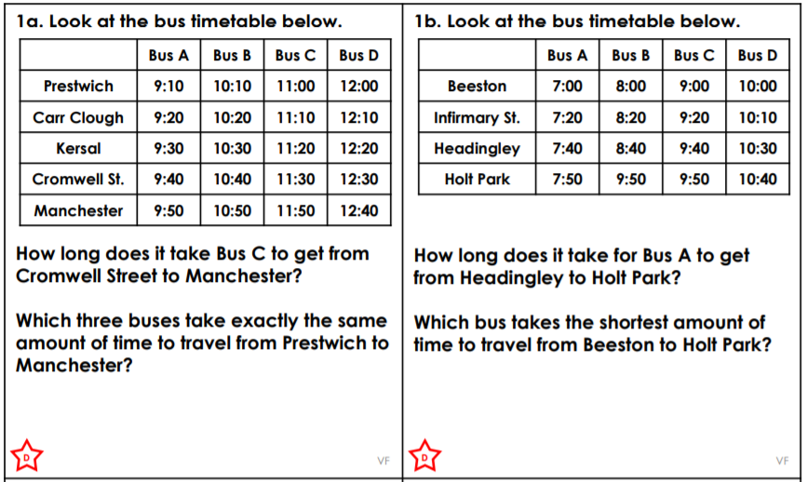
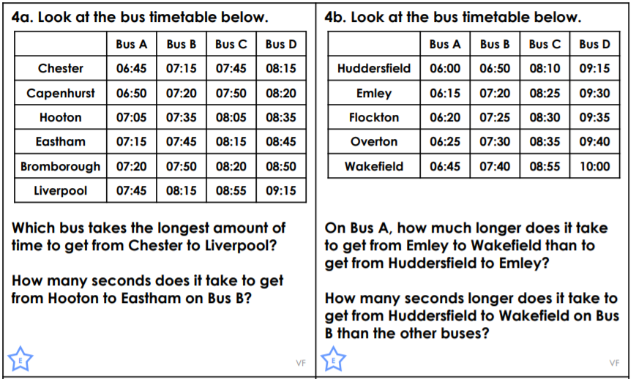

Challenge:
