Wednesday 8th July
Setting description – continued

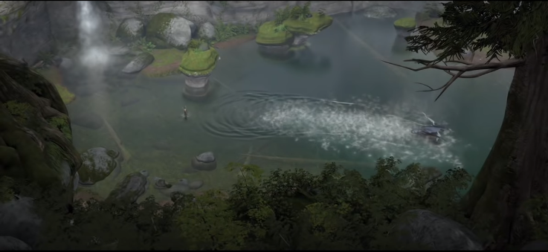
Plot, Spot and Jot
A
1
2
3
B
C
D

You will be given a co-ordinate to locate on the grid. Look carefully at the section of the picture and think about how you would describe it in detail. Use your 5 senses to help you.
Use adjectives, expanded noun phrases, similes and metaphors to create some descriptive writing.
e.g. Tell me how you would describe D3
Notes: branches, leaves, wind, rustle, birds
Sentences:
Standing underneath a dark, mighty, oak tree, Hiccup could hear the gentle, calming wind whistling as it tickled the leaves above him. The branches’ long, twisted fingers reached out silently in search of hope.

Your turn – Locate the co-ordinates below on the grid, and write a setting description for each one.

- Tell me about A2
- Tell me about C3
- Tell me about B2
- Tell me about D1

