Wednesday 8th July
Maths Home learning

Morning Maths
4²
3 x 4 x 5
$$\frac{1}{9}x\frac{1}{2}$$

$$\frac{1}{3}x\frac{2}{3}$$

78 x 4
92 x 5
1,232 ÷ 4
9,987 ÷ 3
2,454 ÷ 6
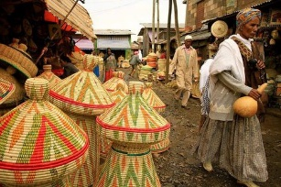

Main Activity – more word problems based on Boy 87

• If 1kg of mphodza (lentils) costs 25 nakfa. How much does 4.5kg cost?
• Shahee (tea) is sold in 2.5 litre jugs for 14 nakfa. How much would it cost for 500ml?
• 24kg of teff (grain) costs 60 nakfa. How much would 18kg cost?
• 0.5kg of cumin costs 55 nakfa. If I spend 495 nakfa, how much cumin can I buy? Write your answer in grams.
• Cardamom costs 140 nakfa for 100g. How much cardamom can I buy for 420 nakfa? Write your answer in kg.

Remember: 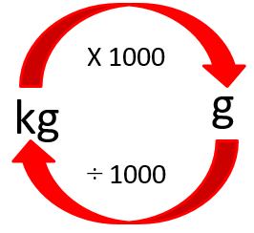 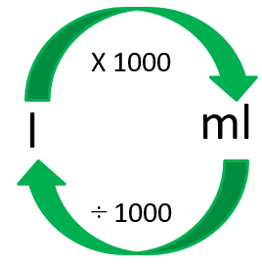
If you need help or a reminder of how to convert measures or how to answer word problems like these, please send a dojo message or email to Mrs Langley or the Y6 home learning team and we will create you a loom video to explain it.

