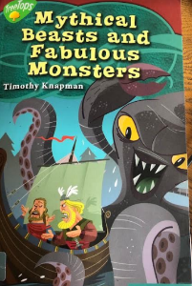
Wednesday 8th July 2020
Reading

‘He loved nature and enjoyed going for long walks to explore the fjord and the countryside around the village.’
Underline/circle/highlight the definition you think explain what a fjord is.
a dense forest in the middle of nowhere
a persistent body of dense ice
a long, deep, narrow body of water that reaches far inland

Compare the brothers Snorri and Halfdan. How would you describe them? What are their personalities like? Fill in a role on the wall for each character.
Halfdan
Snorri

