Questions for pages 116-120
- Why do you think Ron’s cloak was a bit short for him?
- Find and copy the synonym on how the children travelled up the passage away?
- Find and copy the simile which the author has used to describe the lake?

Below is a statement linked to the pages we have read.
Think about the evidence you can think of to agree and disagree with it. Share your ideas with the adults – we would love to see your ideas written down, in voice or video recordings!

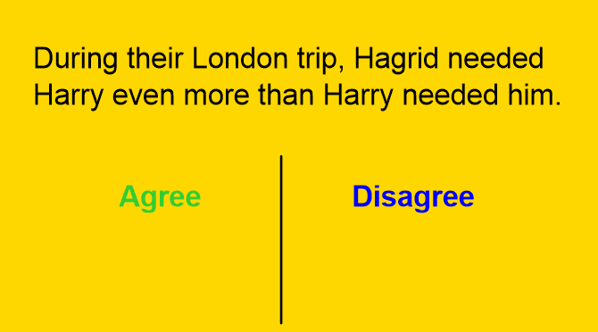
Harry and Ron were right to be nervous.
[Grab your reader’s attention with a great quote from the document or use this space to emphasize a key point. To place this text box anywhere on the page, just drag it.]

