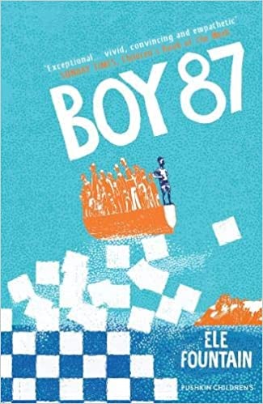
Friday 3rd July 2020
English

LI: To plan and write the opening to my journey story.

- Write a summary of what has happened up to page 40 so far.

- Sequence the following events putting them in chronological order (1-5).

The military shout at Shif and he runs home in a panic

Kidane is causing trouble and teasing Shif and Bini

Shif’s mum tells him that his father isn’t dead

Bini’s mum tells Shif he won’t be coming to school anymore

Shif tells Lemlem to look after mum

Boy 87 |  | My Story
A boat crash – lots of people in the water. A boy appears who reminds Shif of his best friend. | A flashback
Shif and Bini – very clever. Enjoy their lessons and have high aspirations. | School
Square houses with flat roofs. Small, cramped rooms (only 2) | Description of where they live
One day he went to hospital and never came back  Chess reminds Shif of him – made for his sixth birthday | Memory of Dad

