Tuesday 14th July 2020 Guided reading PG 119 - 136
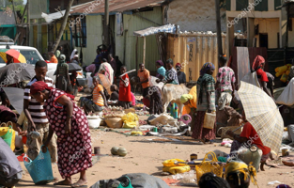
Draw an image of the market scene

How do you know he’s crossed the border/in another country?
___________________________________________________________________________________________________________________________________________________________________________________________________________________________________________________________________________________________________________________________

What does the mother mean when she lies? Why is she lying?
___________________________________________________________________________________________________________________________________________________________________________________________________________________________________________________________________________________________________________________________________________________________________________________________________________________________________________________________________________________________________________________________________
What new information has he discovered?
___________________________________________________________________________________________________________________________________________________________________________________________________________________________________________________________________________________________________________________________________________________________________________________________________________________________________________________________________________________________________________________________________

