Monday 6th July 2020
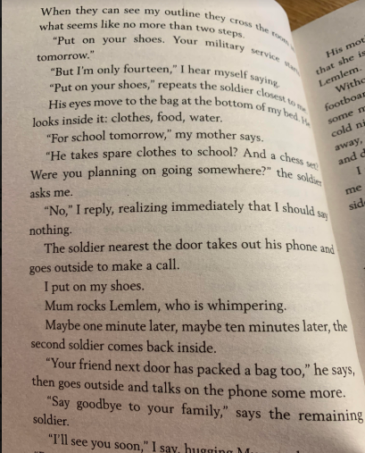
Guided reading Pg 41 – 55
Brain dump – What can you recall from the previous reading? _________________________________________________________________________________________________________________________________________________________________________________________________________________________________________________________________________________________________________________________________________________________________________________________________________________________________________________________________________________________________________________________________________________________________________________________________________________________________________________
Who does the soldier call do you think? Why? What does he say?
____________________________________________________________________________________________________________________________________________________________________________________________________________________________________________________________________________________________________________________________________________________________________________
Why does Shif want to fold inside on himself?
____________________________________________________________________________________________________________________________________________________________

How do we know that they have left the city? Pg 45
____________________________________________________________________________________________________________________________________________________________________________________________

What may have caused the injury to Bini’s face?
____________________________________________________________________________________________________________________________________________________________________________________________

Describe what the boy’s face when they leave the truck?
__________________________________________________________________________________________________________________________________________________________________________________________________________________________________________________________________________________________

How do the boys get their new names?
____________________________________________________________________________________________________________________________________________________________________________________________

Why won’t the boys look the same in two weeks? How will they look? ______________________________________________________________________________________________________________________________________________________________________________________________________________________________________________________________________________________________________________________________________________________________________________________________________________________________________________________________________________________

Can you order these statements?
The boys are given a new name.

Bini is taken.

Shif is taken.

Travel in a lorry.

Stale rolls.

