Thursday 9th July 2020
Guided reading Pg 75 – 85
What do these images represent and mean to the story?
___________________________________________________________________________________________________________________________________________________________________________________________________________________________________________________________________________________________________________________________________________________________________________________________________________________________________________________________________________-----------------------------
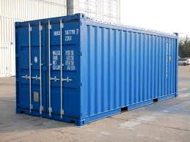
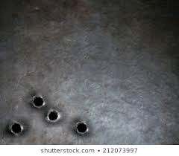
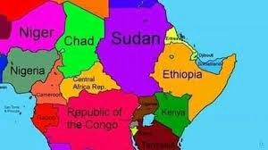

Why do the other men not have much time left? What does Yonas mean?
____________________________________________________________________________________________________________________________________________________________________________________________________________________________________________________________________________________________________________________________________________________________________________________________
Explain why the men feel lucky?
____________________________________________________________________________________________________________________________________________________________________________________________________________________________________________________________________________________________________________________________________________________________________________________________
What’s the escape plan?
__________________________________________________________________________________________________________________________________________________________________________________________________________________________________________________________________________________________
Describe the emotions and the appearance of the men in the containers.

Why have they waited for the boys?

__________________________________________________________________________________________________________________________________________________________________________________________________________________________________________________________________________________

Why do they want to help them?

____________________________________________________________________________________________________________________________________________________________________________________________________________________________________________________________________________________________________________________________________________________________________________________________

What’s the significance of the border?
____________________________________________________________________________________________________________________________________________________________________________________________________________________________________

What are your top 5 points so far about the story?

