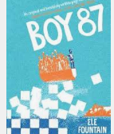
Tuesday 7th July 2020
Guided reading pg Pg 57- 74

Describe the compound, sketch an image.

Describe the ‘cell’. What do you predict happened to the others?
_________________________________________________________________________________________________________________________________________________________________________________________________________________________________________________________________________________________________________________________________________________________________________________________________________________________________________________________________________________________________________________________________________________________________________________________________________________________________________________________________________________________
Journalists – explore why the government might have thought they were dangerous.
________________________________________________________________________________________________________________________________________________________________________________________________________________________________________________________________________________________________________________________________________________________________________________________________________________________________________________________________________________________________________________________________________________________________________________________________________________________________________________________________________________________________________________________________________________________________________________________

