Date:__________________________________
- Shif fetching food from the store.
- Playing chess with Bini
- Seeing the army outside of school.
- Talking to mum about the military school.
- The army arriving at the house.
- Travelling in the truck.
- First night in the container.
- Collecting firewood.
LI: to be able to understand a characters emotional journey throughout a narrative

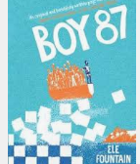
I will be successful if:
- I can recall key events
- I can infer a characters emotion at specific points
- I can use synonyms for emotions
Happy
Sad

Plot the emotions of Shif during the story
Time

