

**Pupil star of the week**

**LL: AM:** Esther- For having some lovely ideas when doing group work

**LL: PM:** Alex M- For joining in with singing and answering questions in his own unique way

**CC: AM:** Ellie- For her amazing work particularly when learning our words of the day which she is able to use confidently

**CC: PM:** Jace- For his enthusiasm towards learning and sharing his amazing ideas during carpet time

**BB:** Ayra Rehman for really good work in English and working hard on writing your name.

**SS 1:** Mikaeel Akhtar - For your super contributions to our book talk discussions. You are a confident communicator.

**SS 1/2:** Arianna Canning-Easy - for always doing her best to achieve.  Well done Arianna you are demonstrating you are a knowledgeable and expert learner.

**DD 2:** Syzmon for always making the correct choice and for being noticed by 3 different members of staff for always being a super star!

**SS 3/4:** Millie-Rose for working incredibly hard all week and producing some amazing independent work.

**BB 3/4**: Amelia Hussain for always being herself, always making the right choices and always working so hard. Well done Amelia!

**WW 3/4:** Ryan Hudson for working independently and with resilience. Well done Ryan for always having a go and not giving up when the work got tricky!

**OO 5:** Matilda Steele - for showing that she cares by helping lots of other children in the class and always trying her hardest with her work. Well done Tilly!

**SS 5:** Muhammad Humayl - for being the second teacher in the classroom during our R.E lessons. His love of Islam is clear and he has helped me with detail I didn’t know or words I struggled to pronounce.

**LL 6:** Oliwia - for always contributing to our community, both in her council roles and by sharing ideas and offering to help in class.

**MM 6:** Aleena - For becoming an expert and knowledgeable learner especially in reading and for making good behaviour choices all week.

**Important Notices**

1. Remember to come to school at your allotted time to ensure social distancing takes place.
2. We have now received our Physical Activity Award for West Yorkshire via e-mail and we will send out more when we receive it.
3. Remember to follow or advice from our previous newsletter: <https://academystjames.com/newsletters-for-september/>
4. Please can you send in photos of what you did during lockdown for a display in school.

**What we’ve done this week**

**Lively Ladybirds:** We have used the song 5 Little Monkeys to practise our counting

**Curious Caterpillars:** This week we have been working with Mrs Louch to complete some of the 50 Things activities. Treasure bags were definitely one of our favourites.

**Brilliant Butterflies:** This week we have been writing retells of what happened in the Island story. We have also created some great collages of colourful birds from the carpet.

**Swooping Starlings:** We have been singing a song to learn the names of the 5 oceans while making papier mache globes. Messy but lots of fun!

**Successful Swans:** What a fantastic week! The children in Successful Swans are working hard to become more independent when working.  They are all becoming excellent learners.

**Daring Ducklings:** This week we have continued our learning of the oceans, we have created our own globes and next week we are going to label them!

**Stupendous Squirrels:** This week we have started writing our own adventure stories based on *Island*. We have also taken part in an amazing music lesson with Mrs Varley.

**Blissful Badgers:** This week we have learnt how to write, edit and re-draft our own stories, as well as working hard on adding and subtracting 10, 100 or 1000 in Maths. We also did our first computing lesson on inputs and outputs and produced a picCollage.

**Wondrous Whales:** We have been working on classification keys for familiar living things in Science and have enjoyed answering questions with either  ‘yes’ or ‘no’ to group animals and plants.  We have been experimenting with textures in art and have been creating pictures using wax crayons and watercolours.

**Omniscient Otters:** I have seen some wonderful work in Otters this week. From Ayisha’s fantastic writing to Nikita and David being super scientists working on water resistance, it has been really lovely to see you all working so hard.

**Super Seals:** Great week this week in Seals. We have been challenging them each day, especially in maths, and each child has risen to the occasion. Well done!

**Leaping Lions:** The adults in Year 6 have reflected on the excellent work we have done in Whole Class Reading this week. We have taken great care in answering inference questions about characters and events in Wonder. The Lions have also been determined to meet their writing targets, and tackled long division positively!

**Magnificent Monkeys:** In science we have been revisiting our learning of separation of mixtures thinking about how we could help remove plastics from the oceans.

**Head Teacher’s comment**

Well the weather has certainly taken a turn for the worse this week! It has been another fantastic week at school with some amazing work on our whole school book the ‘Island’ It was a pleasure to give out our writer of the week awards and have authors like Vashti Hardy commenting on pupils work. As I sit here now I cannot wait until enrichment this afternoon as we celebrate all things ‘physical activity’. I would also like to congratulate Suzanne Louch on being selected for the Bradford Teaching Awards for all her hard work in the community. Finally I would like to thank all the staff who are working tirelessly to support your children. They are doing an amazing job!

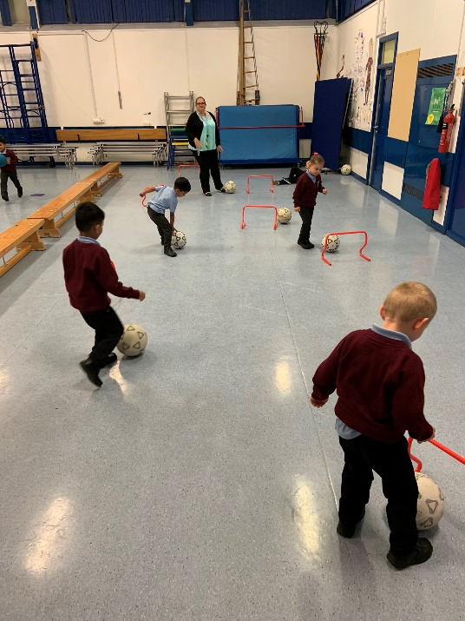

**Photos from this week**

