

**Pupil star of the week**

CC: AM- Tess- For always being caring and being a good role model

PM- Alex- For showing courage and settling into Nursery this week.

BB: Zachary Ross for settling in to school so well, following all the rules and being a really good friend.

SS 1: Ruby - for using resources in the room to work independently in maths this week as **a knowledgeable and expert learner**.

SS 1/2: Samira - for working really hard to achieve her best in everything she is asked to do, she is determined to be a knowledgeable and expert learner.

DD 2:  Marco for becoming a resilient and more confident learner!

SS 3/4: Kai for participating well in class discussions and becoming a much more confident communicator.

BB 3/4: Shelby Wright for really trying hard with her work and trying to be more confident when working independently.

WW 3/4: Jake Kirk for beginning the year with a positive attitude towards all his work.

OO 5: Isaac-Jo Rawlinson for becoming a knowledgeable and expert learner in maths with his ordering of numbers.

SS 5: Baraka Myekano - for his great effort in all subjects. I have been really impressed with his adventurous writing. Keep this up!

LL 6: Amira: for showing great care with her approach to learning, and applying her talent and expertise for art.

MM 6: Kelly: For working very hard in all lessons and settling well back into school life.

**Important Notices**

1. Please remember to bring your children to the school door in the morning and not to let them walk down on their own.
2. You can bring one book bag to school which everything can go into and reading books will come in and out of school but will stay in that class.
3. Make sure you keep reading with your child- it is a huge help and having been off school for a long time this will really help
4. Thank you for sending your children in their PE kit on the day they have PE.  This is making a huge difference to the amount of lesson time and is safer for school.
5. A reminder that all pupils must be brought and picked up from school by somebody who is 18 or above.
6. Breakfast club has begun and if you would like a place please e-mail Rebecca Oxley or the school office on [office@academystjames.com](mailto:office@academystjames.com)
7. Check out our new class pages on the school website <https://academystjames.com/> All information is in here including class letters and curriculum overviews.
8. Thank you for supporting our social distancing rules- remember to keep 2m apart when we are walking down the drive.  We know there has been a queue at the top so we will looking at this in the coming days

**What we’ve done this week**

**Curious Caterpillars:** This week we have been learning the rules and routines of our classroom and learning how to use all the areas.

**Brilliant Butterflies:** This week we have been looking at a picture book called window. We have collaged our own window frames and painted pictures of what we see out of our windows.

**Swooping Starlings:** We have made trips to the local area and around the school grounds, chosen features to photograph and taken our own digital photographs. It gave us lots to talk about.

**Successful Swans:** This week we have set up our home school reading.  Lots of children have been reading at home. Please keep up the good work and remember to sign your child's reading journal.

**Daring Ducklings:** This week we have been learning about our local area! We learnt what human and physical features are and we tried to find them in our local environment! Great working Ducklings!

**Wondrous Whales:** This week we have learnt how to paint with salt! We have been creating seascapes.

**Stupendous Squirrels:** This week we have been working hard on our classroom environment. The children have produced some fantastic artwork including a small world set linked to our whole school book ‘Island’.

**Blissful Badgers:** This week we have been learning to draw what we read in Guided Reading so that we can understand the vocabulary and picture what is happening in the story.

**Omniscient Otters:** This week we have been working hard on our place value, rounding and ordering numbers. We have also been looking at developing our geography skills by reading maps and using compass points. The children have done a great job all week!

**Super Seals:** I have been really impressed by the children’s writing this week. They have been very adventurous with their vocabulary and it’s awesome to see them trying to apply it to their work.

**Leaping Lions:** I have been delighted with our creativity throughout the week in a variety of subjects. In art, we took great care with our Island-inspired Caribbean artwork, and in Reading, we have thought deeply about how characters might be feeling in the early chapters of Wonder.

**Magnificent Monkeys:** This week we have been learning about place value in maths and applying it to real life problems. We have been using our retrieval and inference skills during guided reading and have made some fantastic prediction about our class book.

**Head Teacher’s comment**

What an amazing first full week back at school it has been. I have been overjoyed and very proud of all the work the pupils have been doing. Thank you for your support too as it has been unbelievable in what I know has been a difficult time for everyone. I would like to say a huge thank you to the staff team who have been magnificent and done everything asked of them to try and make school as safe and enjoyable as possible.

My three highlights this week were walking into Year 6 and seeing them laughing with Mrs Allingham whilst playing curriculum Jenga, seeing Nikita smile as she showed me her work and finally the welcome I got in Reception when I walked in on Tuesday- it made me smile a lot!

I hope you have a lovely weekend and thank you for all your support.

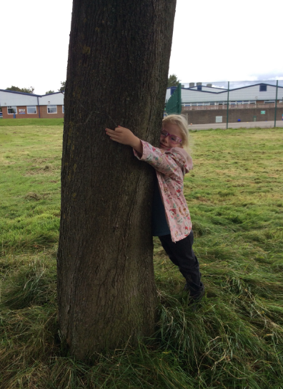

**Photos from this week**

